Day & Zimmermann Supplier Portal Guide

Important Note:
If you are an existing D&Z supplier & have received your credentials, visit the Day & Zimmermann Supplier Portal to:
- Manage existing supplier profile
- Access Purchase Orders (PO) history
- Submit invoices
- View invoice and payment status

We recommend that you add the domain @dayzim.com to your safe senders list in your email client to ensure that you always receive important communications. For Day & Zimmermann portal-related questions, contact: supplierenablementNA@dayzim.com

Sign in with your user name (email) and password. There is two-step authentication in place; you will receive a one-time passcode (OTP) via email for the portal. The OTP is valid for only 10 minutes.
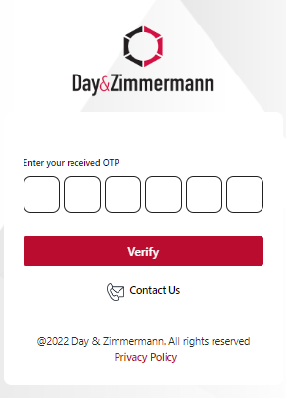

Sample OTP/ verification code email
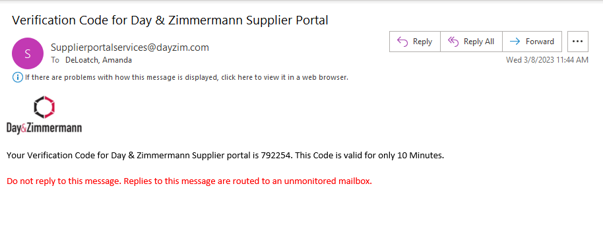

Viewing Supplier Profile and Purchase Orders
Use the tabs at the top of the page to switch between your Supplier Profile and available Purchase Orders.
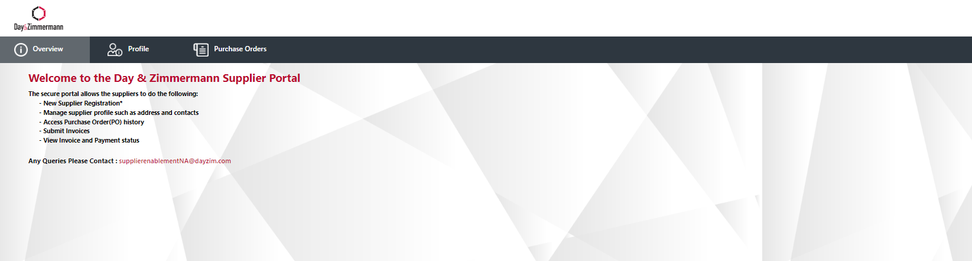

Editing Supplier Profile
- Click the Profile button at the top of the page to display supplier profile.
- To submit updates, select the edit button.
- You will be able to update the following:
  - Company name *requires updated W9 form
  - Street address *requires updated W9 form
  - Phone, DUNS, Primary NAICs
  - Payment Information * requires updated EFT Form and voided check/bank letter, in addition to responding against ‘challenge questions’; see page 4 of this Guide for additional information.
- Edits to Contact Email, Business Classification, Employer Identification Number (EIN) and Social Security Number (SSN) are not permitted. Contact supplierenablementNA@dayzim.com for additional information.
- All submitted updates will be reviewed by the D&Z Supplier Management Team prior to them being made effective in the portal.
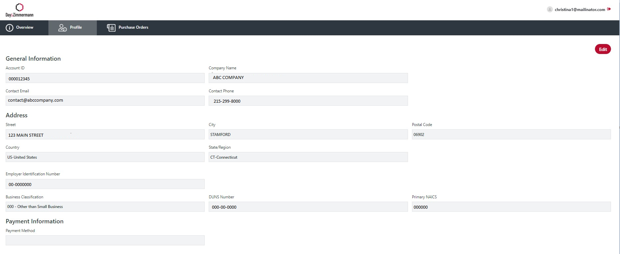

Managing Payment Accounts
Many companies are seeing an increase in fraud, specifically around bank account changes. Because of this, we have implemented a requirement whereby supporting documentation is required to validate banking information.

For all suppliers, when requesting a banking change through the portal, we request one of the following documents:

- A letter from your/ your Company's bank with the bank details (to include account name, bank name, bank routing numbers, account number, IBAN/Swift Code).
- A cancelled/ voided check.

in addition to the completion of the challenge questions:

- Last deposit date from DZG
- Last deposit amount from DZG

If no deposits have been received yet, select the designated check box.

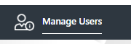
Managing Users
- To add a new user, select the ‘Manage Users’

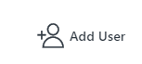
- On the User List page, click “Add User”

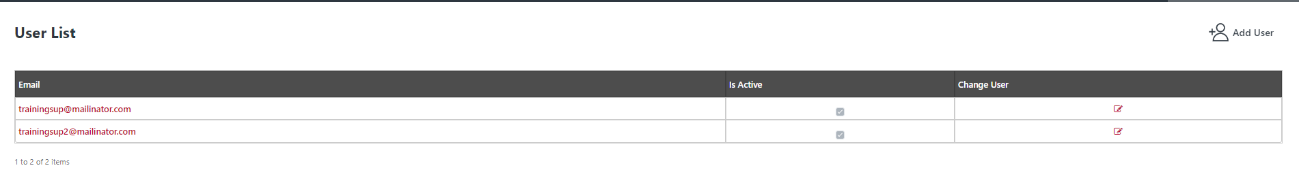
- Enter new user’s email address and save. An email will be sent to the new user to create their new password.

Deactivate Users
- Select the ‘Profile’ tab and select ‘Manage Users’
- On the User List page, click the edit icon in the change user column.
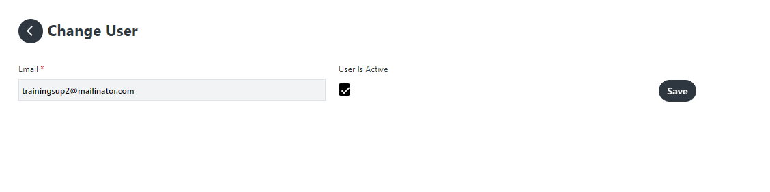
- On the Change User page uncheck User is Active. Save

Viewing Purchase Orders
5 years’ worth of Purchase Order History is available in the portal for review. POs issued via Ariba are available in the portal for invoicing.
Note: Suppliers may see PO’s that they were not issued, that were ‘internally’ created to make a payment.
POs can be searched by PO# (must use CAPS), PO status or Date Range.
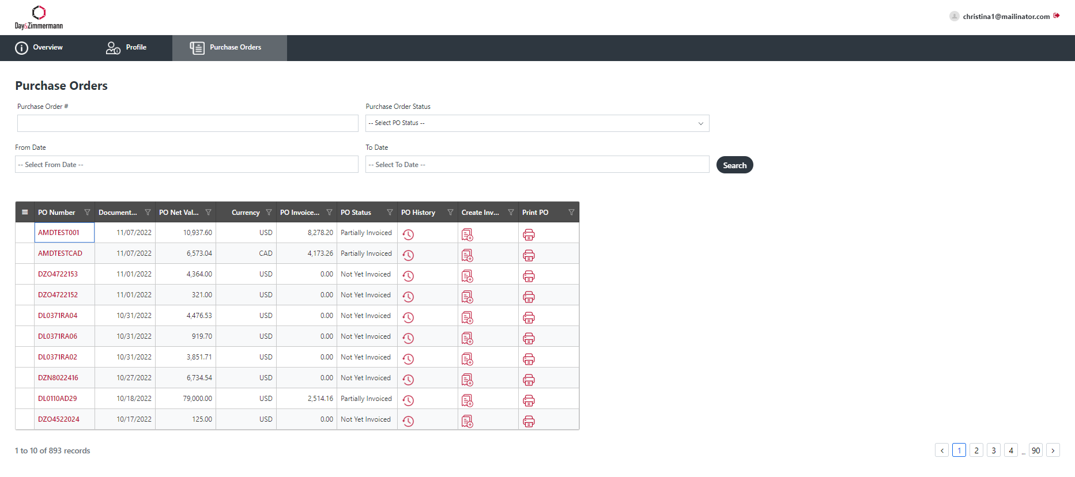
Status of the PO, PO History, Create invoice and a PDF view/print of the PO can be accessed from the dashboard view. 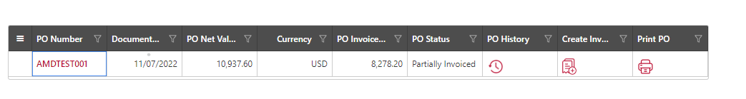
Sample PO History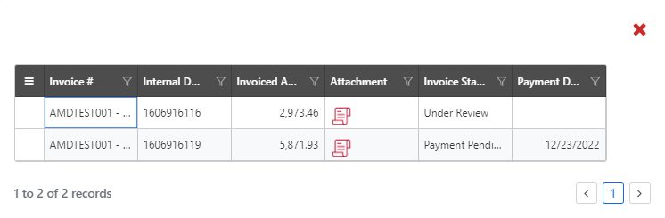

Invoices
- Select PO from dashboard.
- Select the Create Invoice button (found on dashboard or top right in the PO).
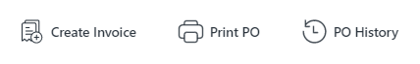
- Fill in all required fields:
  - Invoice #
  - Invoice Date (back date allowed up to 3 days only)
  - Shipping/Freight charges (where applicable)
    - If Tax on Shipping/Freight applies, select the shipping/freight tax indicator
  - ‘Remit to’ drop down will only be available if there are remit-to addresses linked in the supplier database
  - Upload your organization’s invoice

Invoice a Planned Service PO:
- Follow Steps 1-3 above on how to create an invoice.
- PO type will show as Services – P.
- Select the Purchase Order line item to invoice, then select the planned service line item(s). You will only be able to update the line item invoice quantity.
- The submit button will become available once all required fields are filled in.
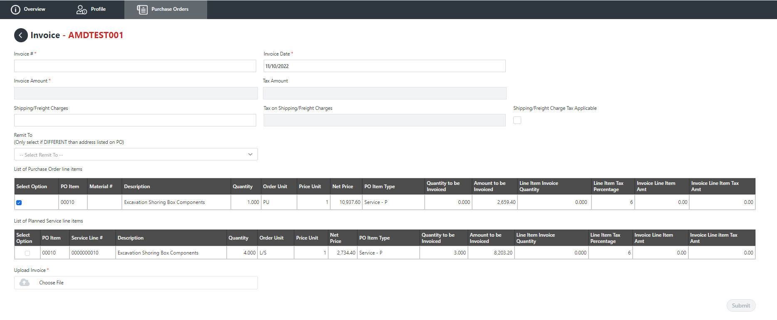

Invoice an Unplanned Service PO:
- Follow Steps 1-3 from page 7 on how to create an invoice.
- PO type will show as Services – U.
- Select the Purchase Order line item(s) to invoice, then select Add Service Line Item.
- A new section with the list of unplanned service lines will be available.
  - Fill in the description, quantity, service line (UOM) unit of measure (must be in uppercase), Net Price and Price Unit.
  - Additional service lines may be added by clicking the blue box with the plus sign under Action. Lines may be deleted by clicking the red trash can.
- The submit button will become available once all required fields are filled in.
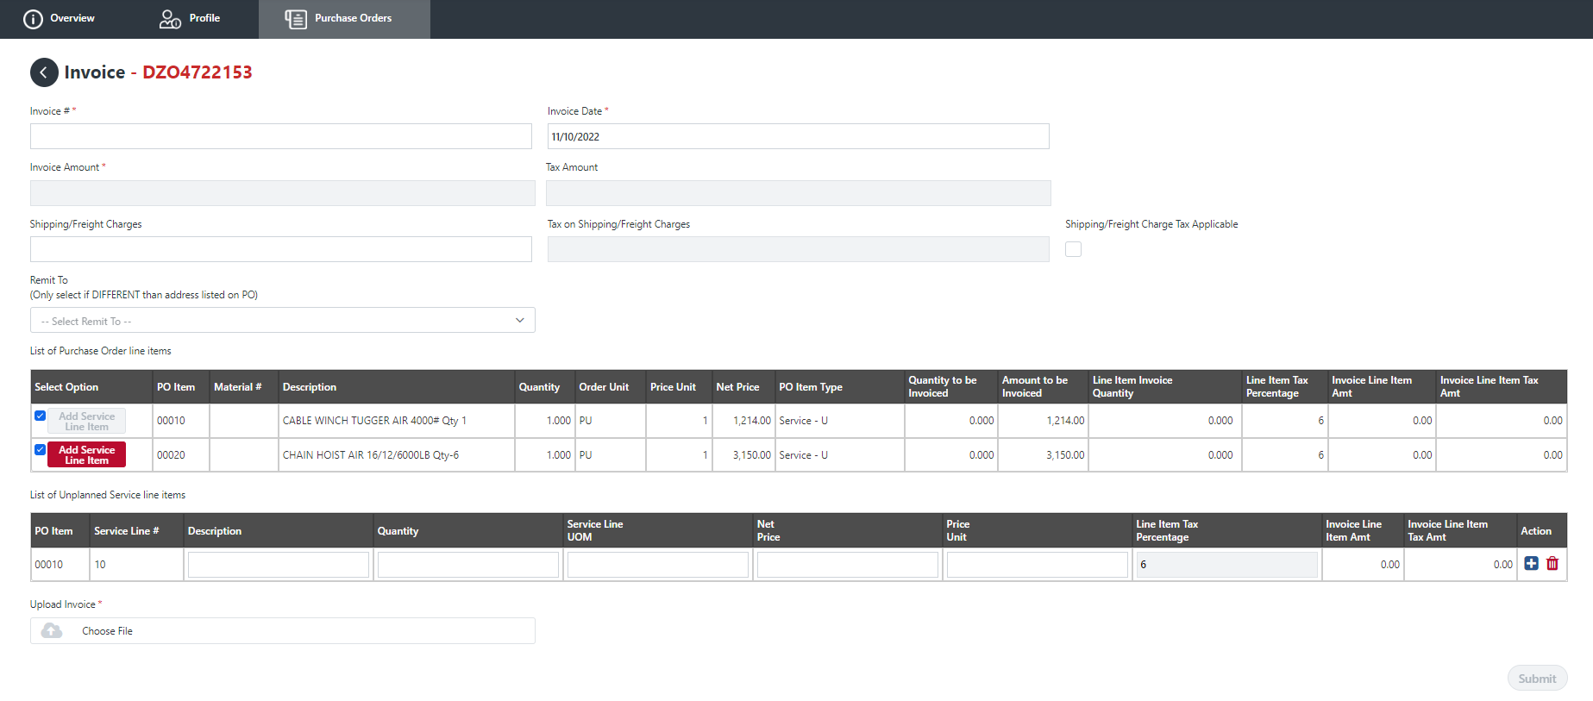

Invoice – Material PO
- Follow Steps 1-3 from page 7 on how to create an invoice.
- PO type will show as Material.
- Select the Purchase Order line item(s) to invoice. You will only be able to update the line item invoice quantity.
- The submit button will become available once all required fields are filled in.

