Day & Zimmermann Supplier Portal - New Supplier Registration Guide

Important Note:
We recommend that you add the domain @dayzim.com to your safe senders list in your email client to ensure that you always receive important communications. For Day & Zimmermann portal-related questions, contact: supplierenablementNA@dayzim.com

New Supplier Registrations
New suppliers will be sent a link via email to create portal password. User Name is the email that the invitation was sent to.
There is two-step authentication in place; you will receive a One-time Passcode (OTP) via email for the portal. The OTP is valid for only 10 minutes.

Sample OTP/ verification code email
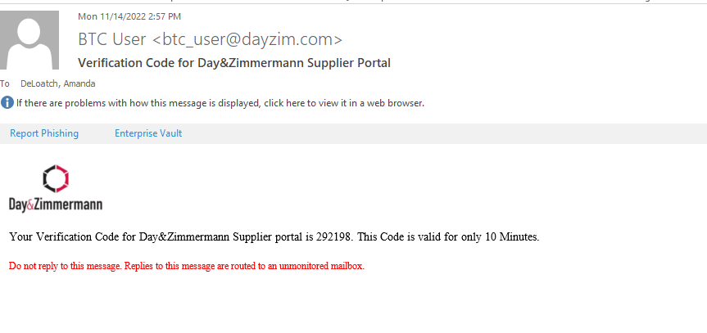

Create new password – Enter password of choice. Then Submit.
Log-on will refresh after password is set and you will need to sign in with the newly created password.
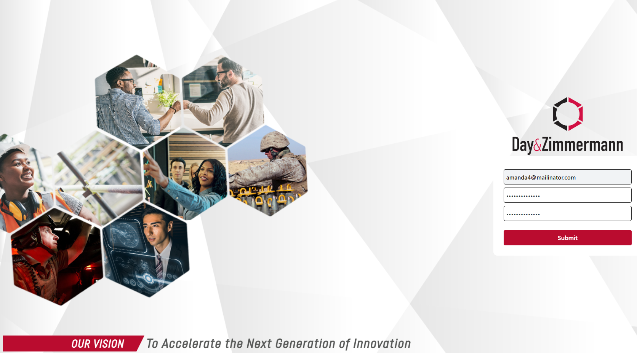

The Supplier Information section contains fields needed to build the supplier record. All required fields are marked with an asterisk (*).
Note:
- Form may be saved as a draft and submitted at a later time.
- The submit button will not be available until the code of conduct is downloaded and acknowledged.
Required documentation:
- Current revision W9 as found on IRS.gov or W8 form
- Voided Check or Bank Letter for ACH verification
- Certificates and supporting documentation related to Business Classification status
