Day & Zimmermann Supplier Portal Guide

Important Note:
If you are an existing D&Z supplier & have received your credentials visit the Day & Zimmermann Supplier Portal to:
- Manage existing supplier profile.
- Access Purchase Orders (PO) history
- Submit invoices
- View invoice and payment status

We recommend that you add the domain @dayzim.com to your safe senders list in your email client to ensure that you always receive important communications. For Day & Zimmermann portal-related questions, contact: supplierenablementNA@dayzim.com

Sign in with your user name (email) and password. There is two-step authentication in place; you will receive a one-time passcode (OTP) via email for the portal. The OTP is valid for only 10 minutes.
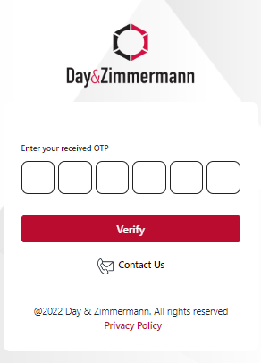
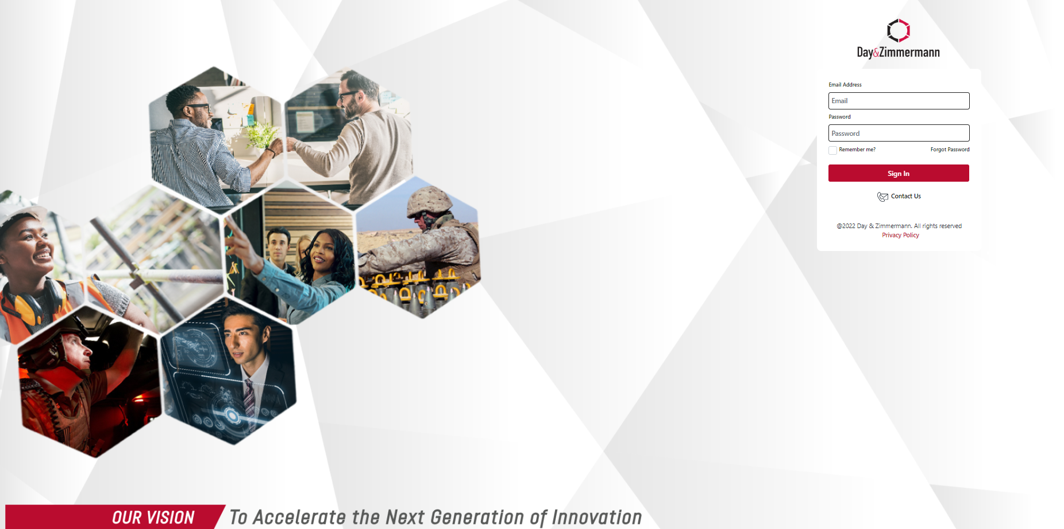

Sample OTP/ verification code email
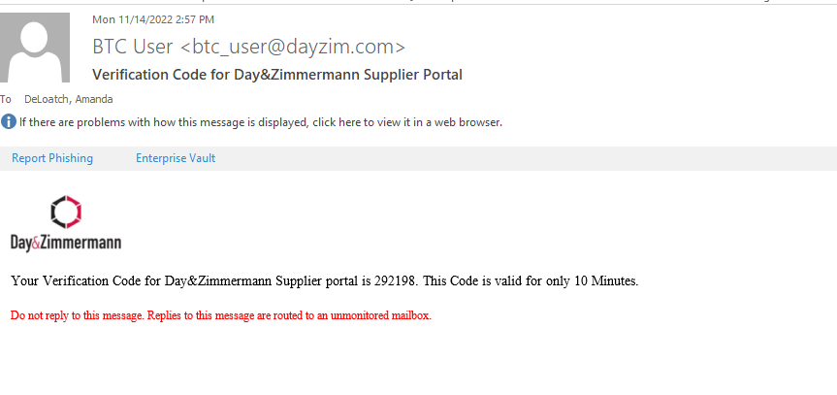

Viewing Supplier Profile and Purchase Orders
Use the tabs at the top of the page to switch between your Supplier Profile and available Purchase Orders.
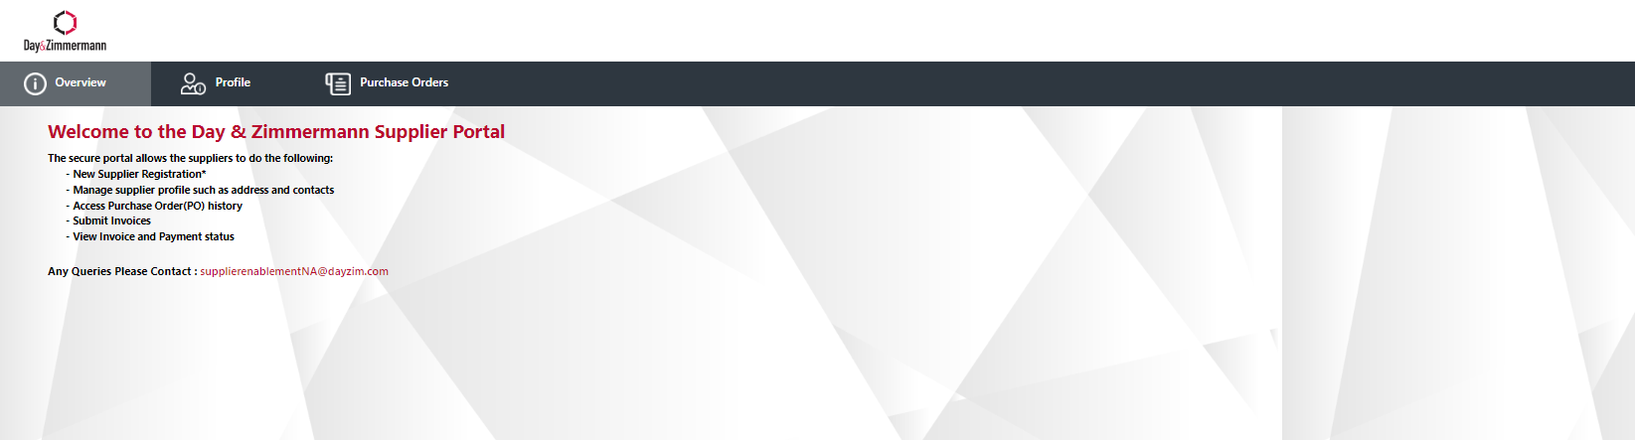

Editing Supplier Profile
- Click the Profile button at the top of the page to display supplier profile.
- To submit updates, select the edit button.
- You will be able to update the following:
  - Company name *requires updated W9 form
  - Street address *requires updated W9 form
  - Phone, DUNS, Primary NAICs
  - Payment Information * requires updated EFT Form and voided check/bank letter
- Edits to Contact Email, Business Classification, Employer Identification Number (EIN) and Social Security Number (SSN) are not permitted. Contact supplierenablementNA@dayzim.com for additional information.
- All submitted updates will be reviewed by the D&Z Supplier Management Team prior to them being made effective in the portal.
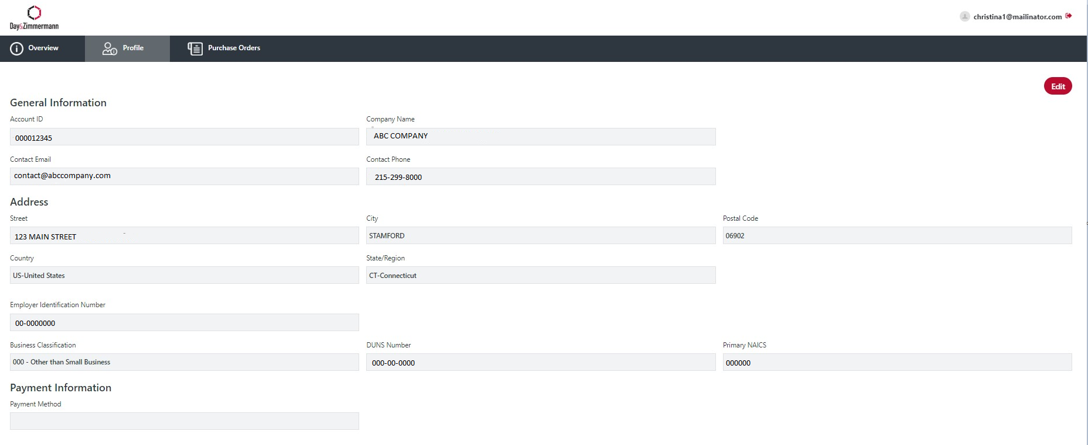

Viewing Purchase Orders
5 years’ worth of Purchase Order History is available in the portal for review. POs issued via Ariba are available in the portal for invoicing.
Note: Suppliers may see PO’s that they were not issued, that were ‘internally’ created to make a payment.
POs can be searched by PO# (must use CAPS), PO status or Date Range.
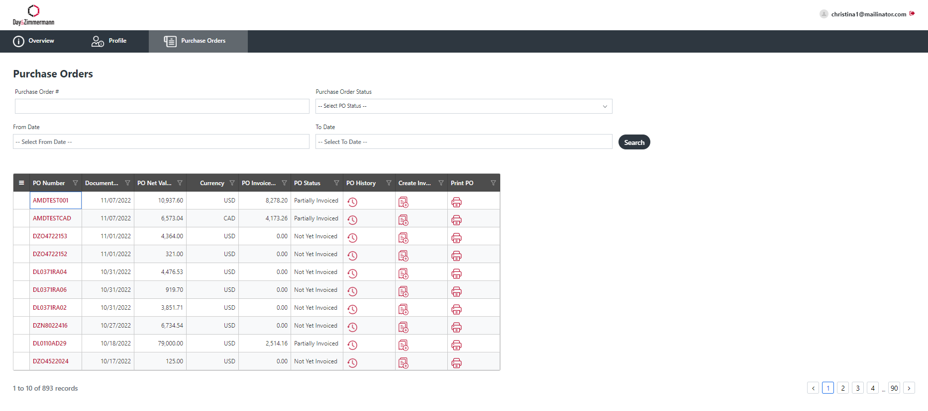
Status of the PO, PO History, Create invoice and a PDF view/print of the PO can be accessed from the dashboard view. 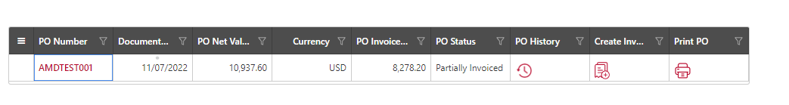
Sample PO History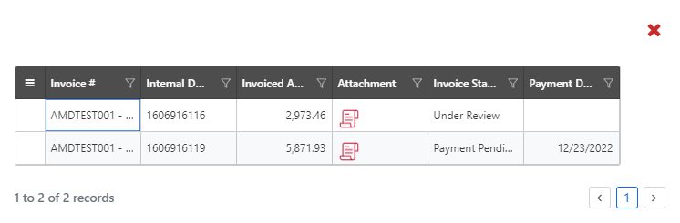

Invoices
- Select PO from dashboard.
- Select the Create Invoice button (found on dashboard or top right in the PO).
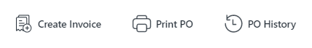
- Fill in all required fields:
  - Invoice #
  - Invoice Date (back date allowed up to 3 days only)
  - Shipping/Freight charges (where applicable)
    - If Tax on Shipping/Freight applies, select the shipping/freight tax indicator
  - Remit to drop down will only be available if there are remit-to addresses linked in the supplier database
  - Upload your organization’s invoice
  - Note that tax cannot be adjusted and will match the PO. Contact your D&Z Supply Chain Specialist if you disagree with the listed tax.

Invoice a Planned Service PO:
- Follow Steps 1-3 above on how to create an invoice.
- PO type will show as Services – P.
- Select the Purchase Order line item to invoice, then select the planned service line item (s). You will only be able to update the line item invoice quantity.
- The submit button will become available once all required fields are filled in.
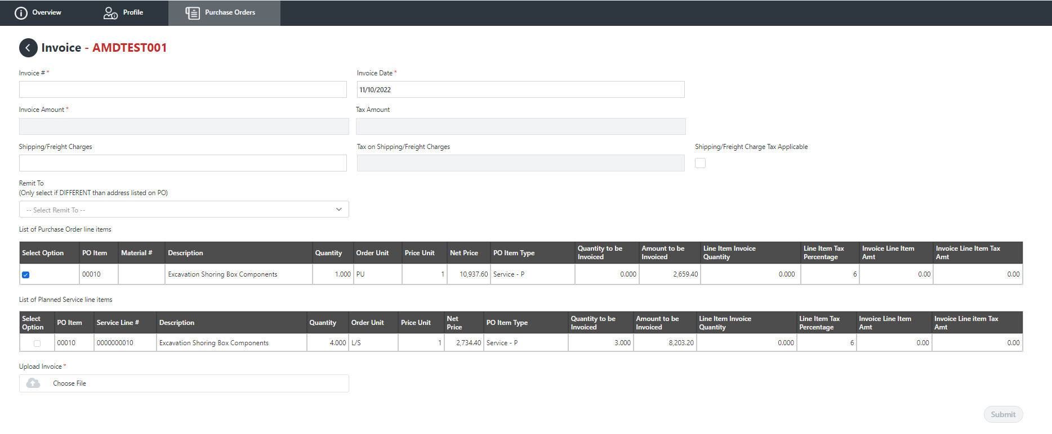

Invoice an Unplanned Service PO:
- Follow Steps 1-3 from page 5 on how to create an invoice.
- PO type will show as Services – U.
- Select the Purchase Order line item(s) to invoice, then select Add Service Line Item.
- A new section with the list of unplanned service lines will be available.
  - Fill in the description, quantity, service line (UOM) unit of measure (must be in uppercase), Net Price and Price Unit.
  - Additional service lines may be added by clicking the blue box with the plus sign under Action. Lines may be deleted by clicking the red trash can.
- The submit button will become available once all required fields are filled in.
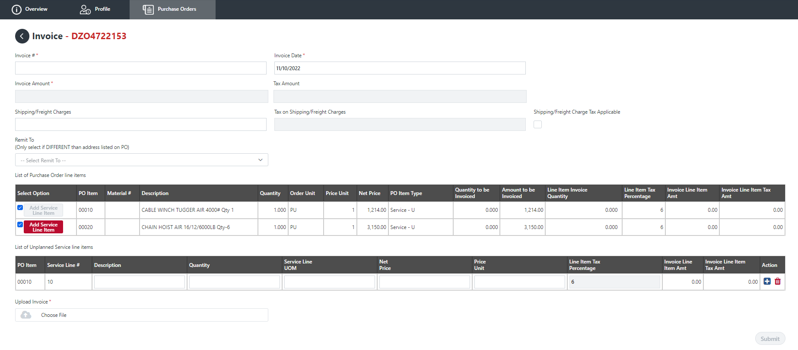

Invoice – Material PO
- Follow Steps 1-3 from page 5 on how to create an invoice.
- PO type will show as Material.
- Select the Purchase Order line item(s) to invoice. You will only be able to update the line item invoice quantity.
- The submit button will become available once all required fields are filled in.

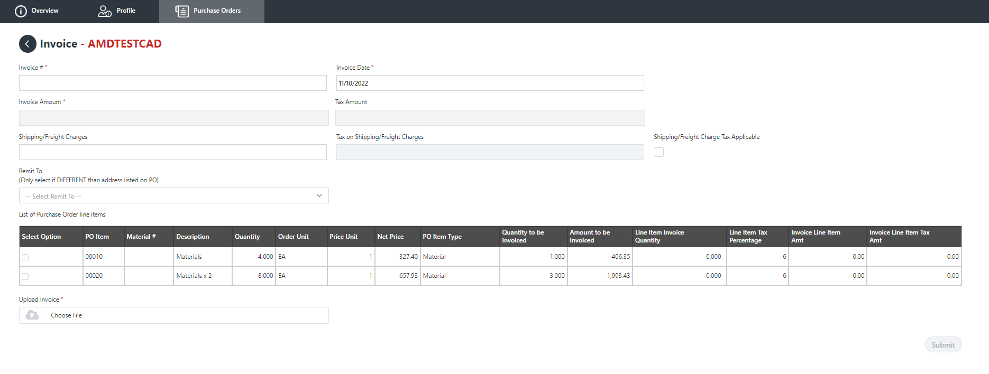
New Supplier Registrations
New suppliers will be sent a link via email to create portal password. User Name is the email that the invitation was sent to.
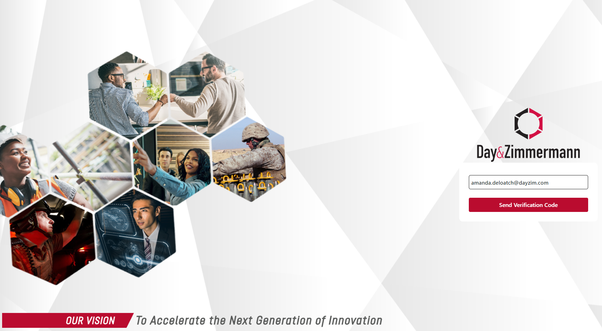
There is two-step authentication in place; you will receive a One-time Passcode (OTP) via email for the portal. The OTP is valid for only 10 minutes.
Sample OTP/ verification code email

Create new password – Enter password of choice. Then Submit.
Log-on will refresh after password is set and you will need to sign in with the newly created password.
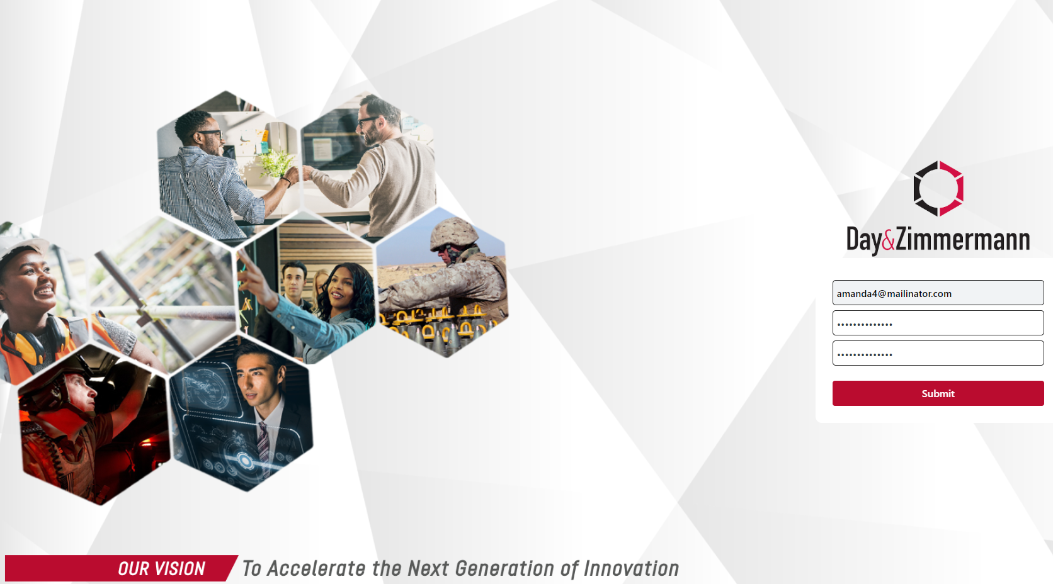

The Supplier Information section contains fields needed to build the supplier record. All required fields are marked with an asterisk (*).
Note:
- Form may be saved as a draft and submitted at a later time.
- The submit button will not be available until the code of conduct is downloaded and acknowledged.
Required documentation:
- Current revision W9 as found on IRS.gov or W8 form
- Voided Check or Bank Letter for ACH verification
- Certificates and supporting documentation related to Business Classification status
